**ASSIGNMENT 4**

1. Apply Linear Regression to the provided dataset using underlying steps.

a. Import the given “Salary_Data.csv”

b. Split the data in train_test partitions, such that 1/3 of the data is reserved as test subset.

c. Train and predict the model. d. Calculate the mean_squared error e. Visualize both train and test data using scatter plot.

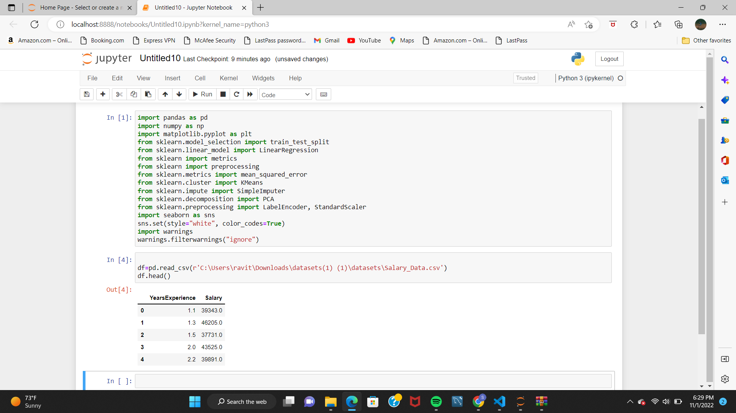

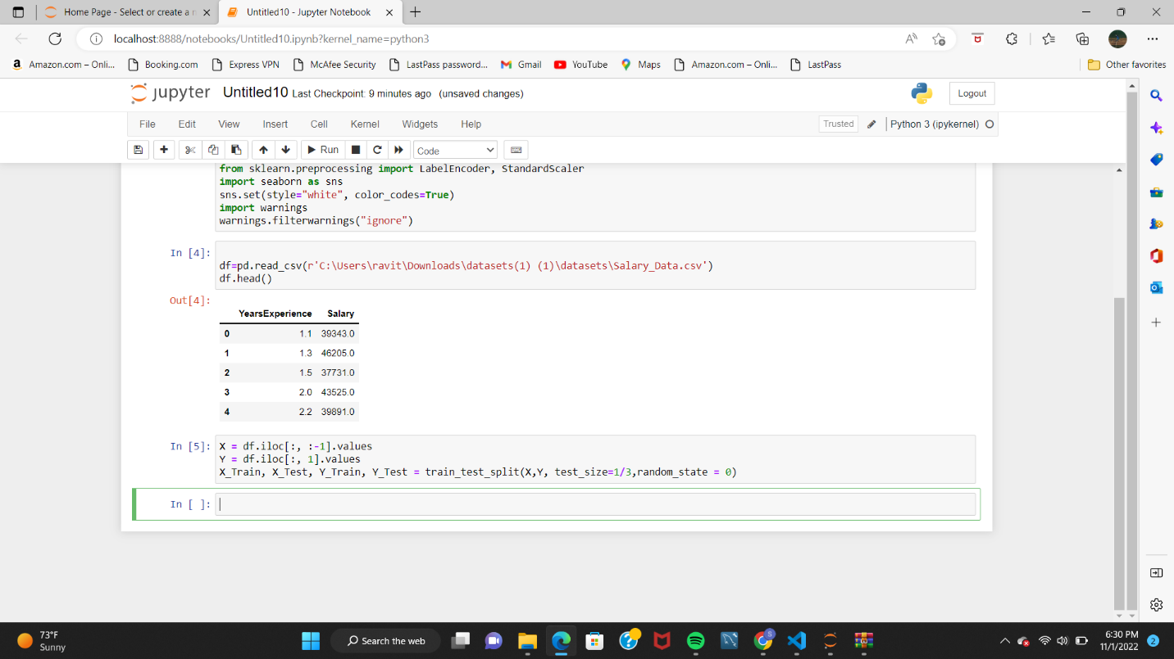

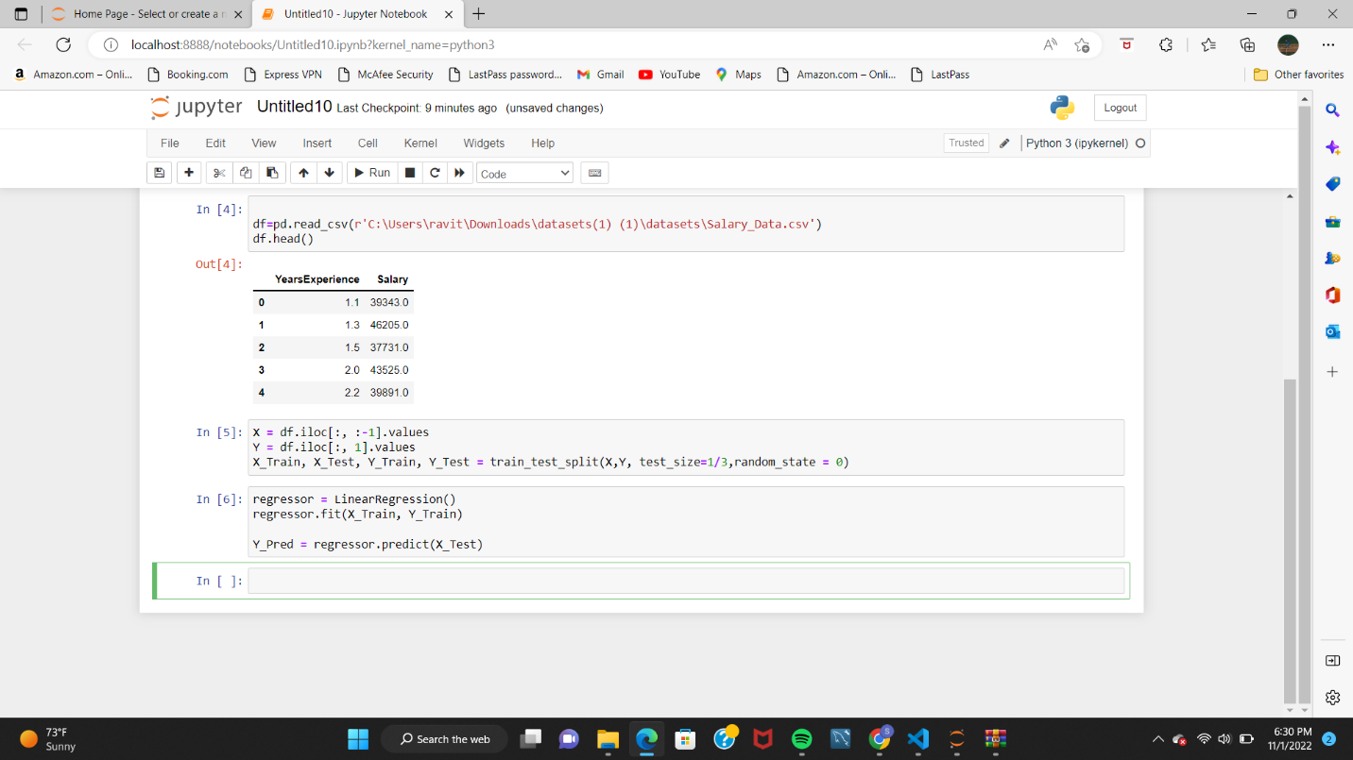

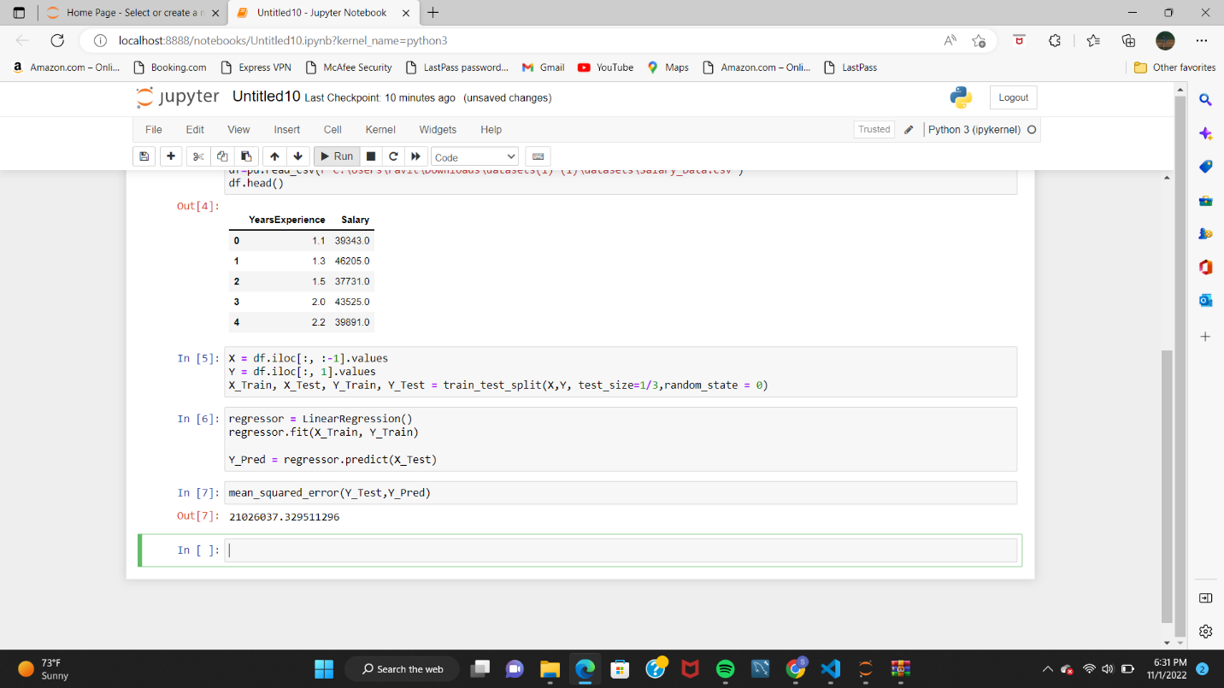

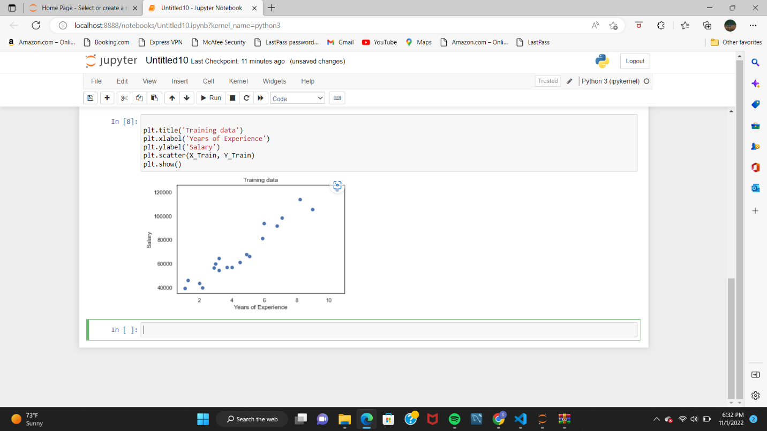

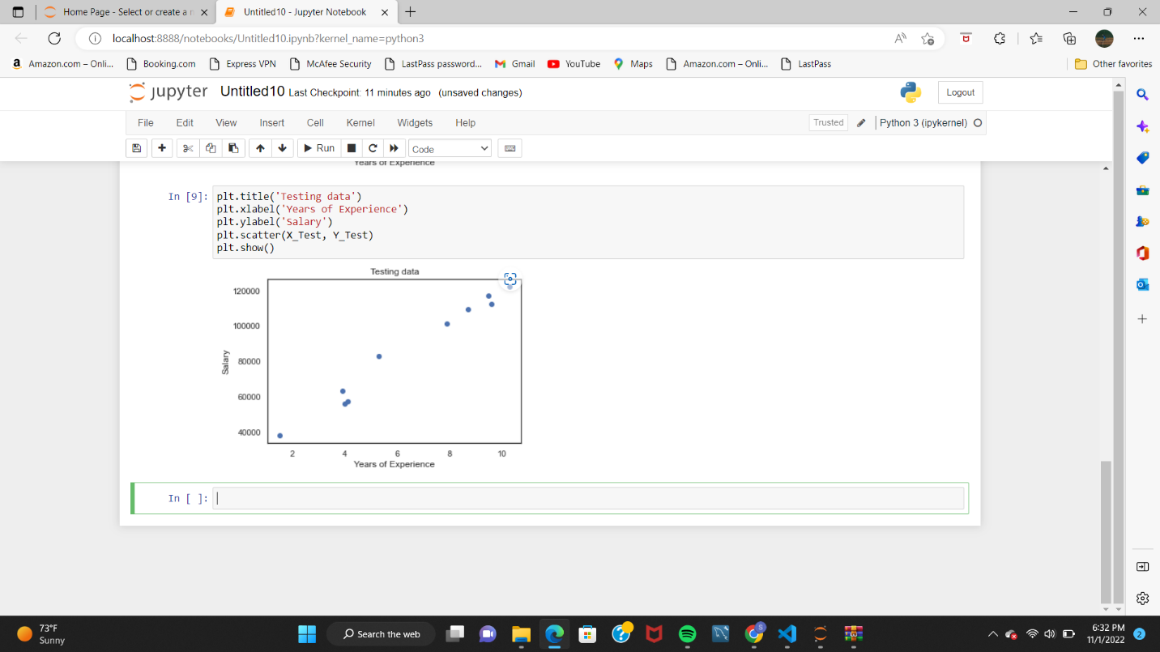

2. Apply K means clustering in the dataset provided:

• Remove any null values by the mean.

• Use the elbow method to find a good number of clusters with the K-Means algorithm

• Calculate the silhouette score for the above clustering.

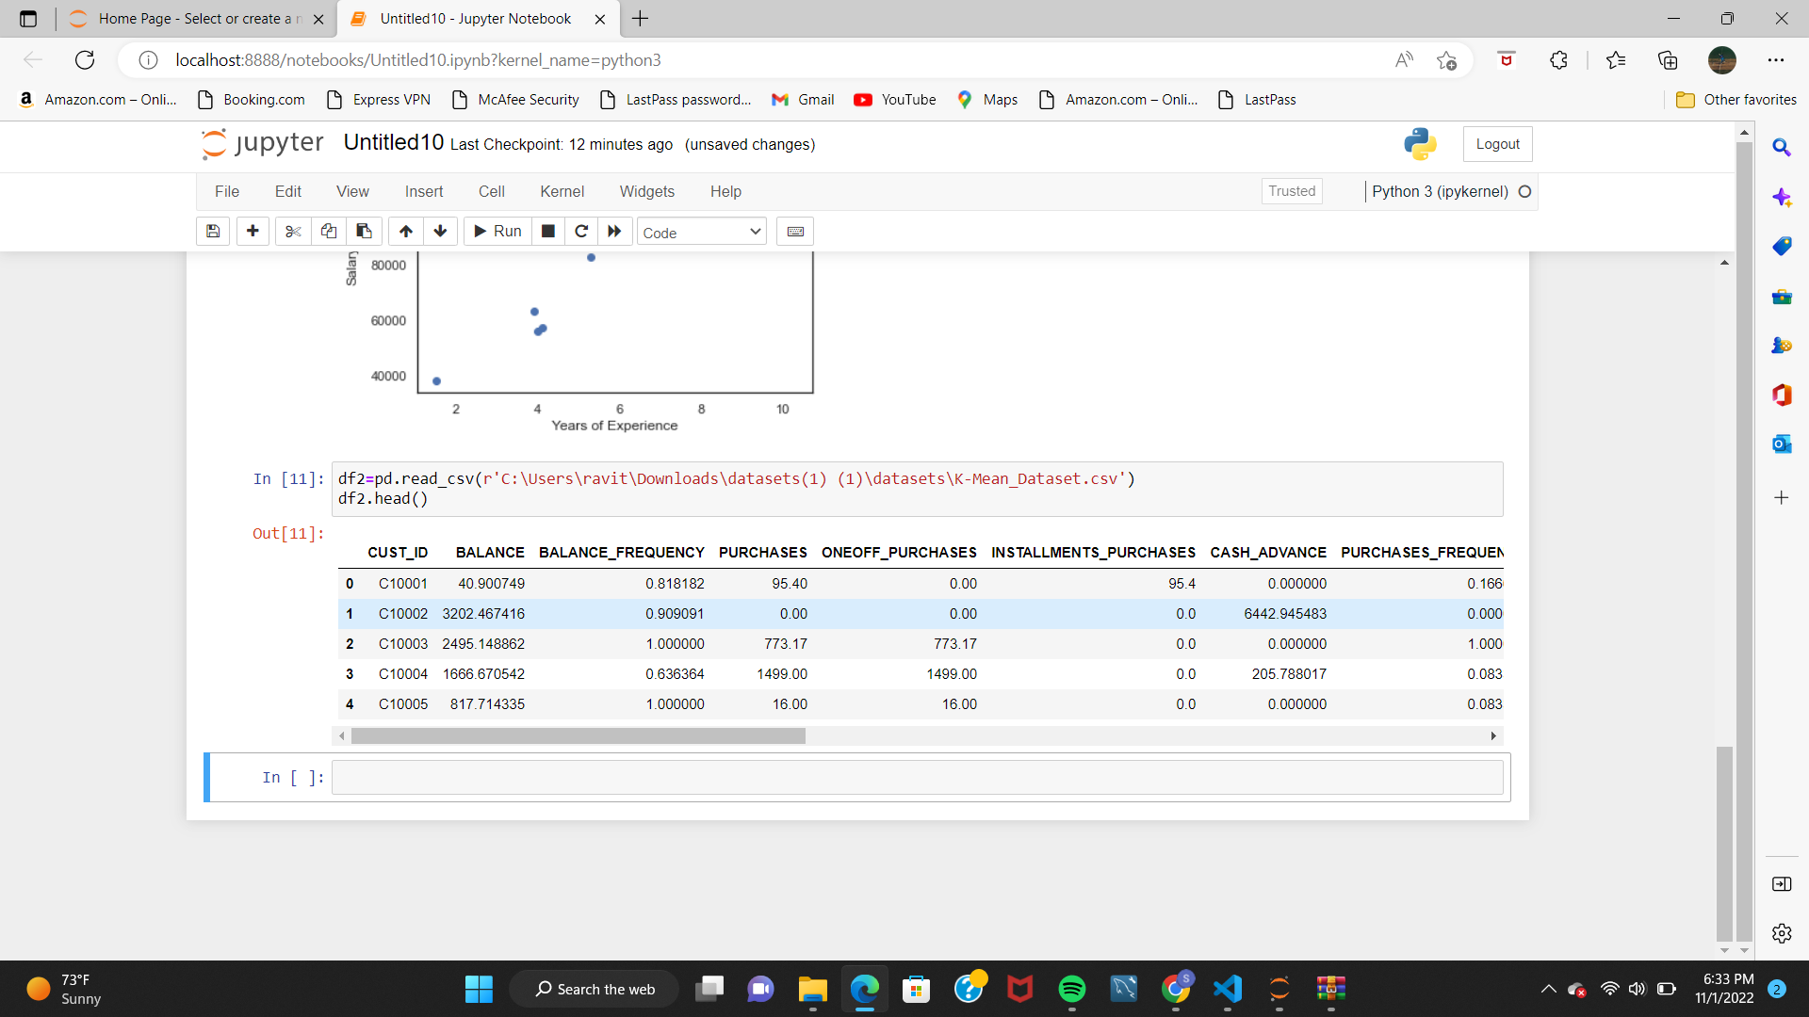

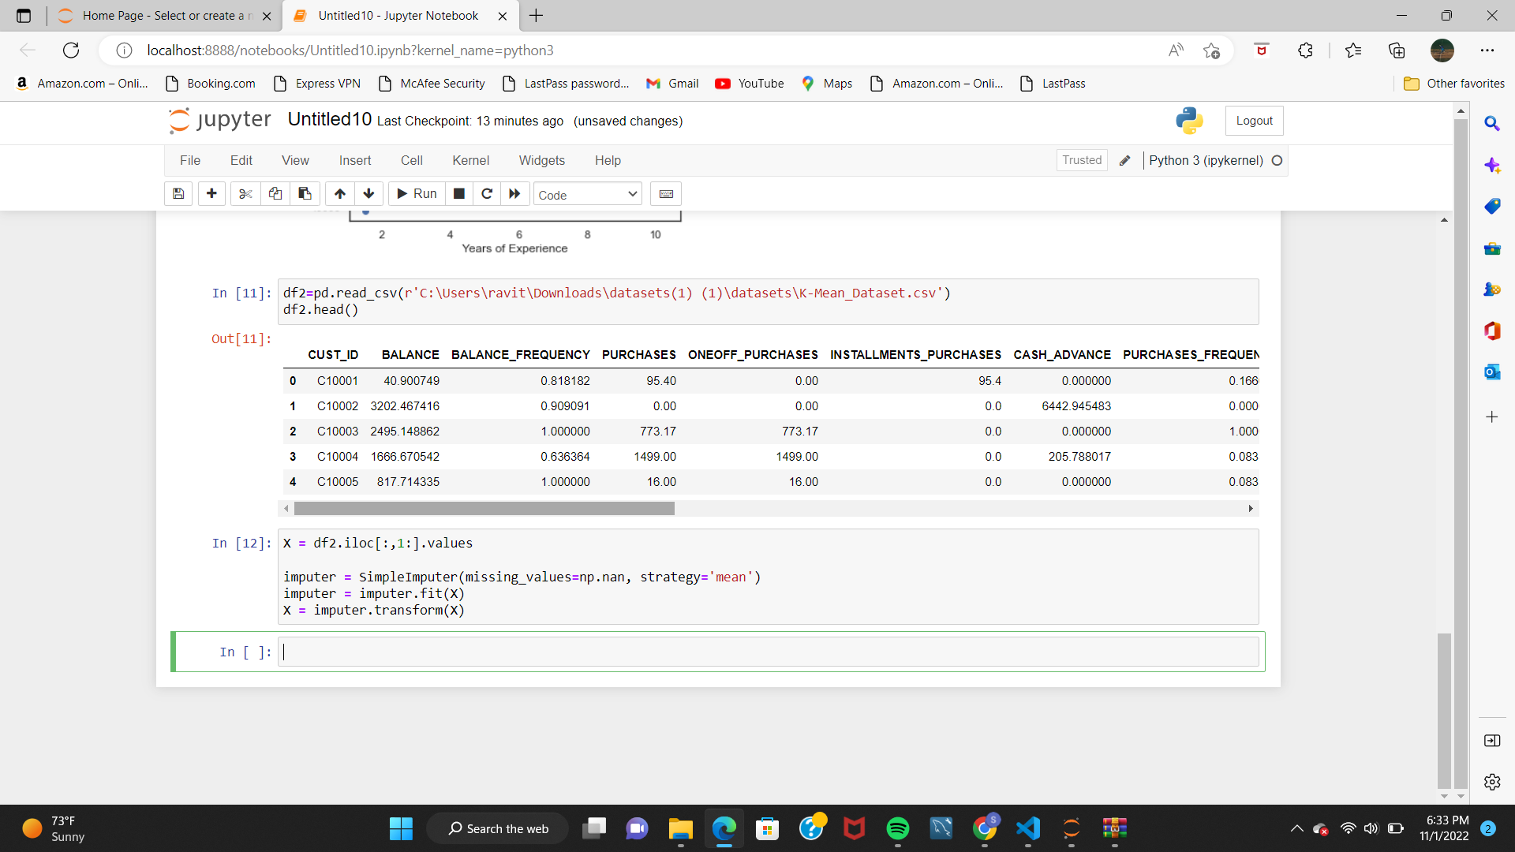

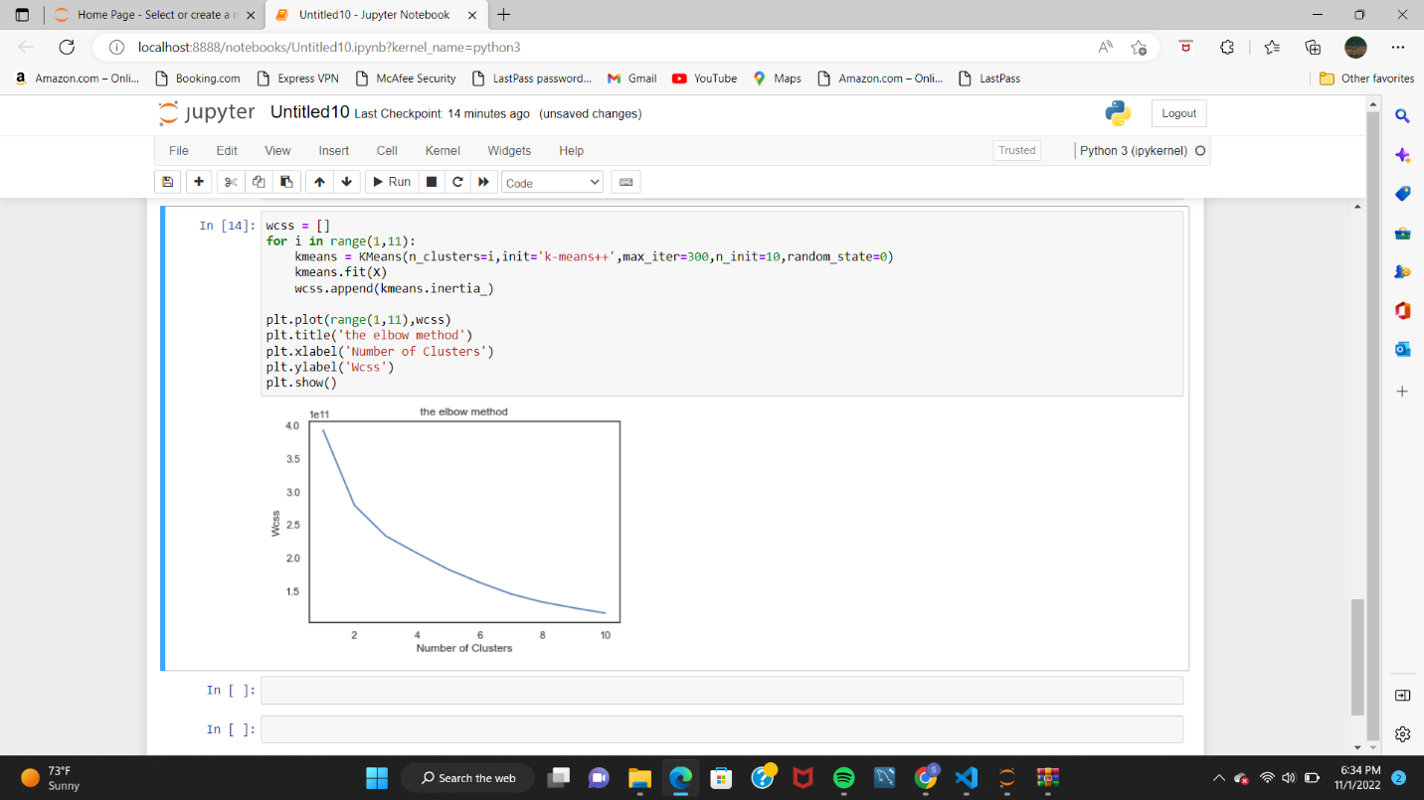

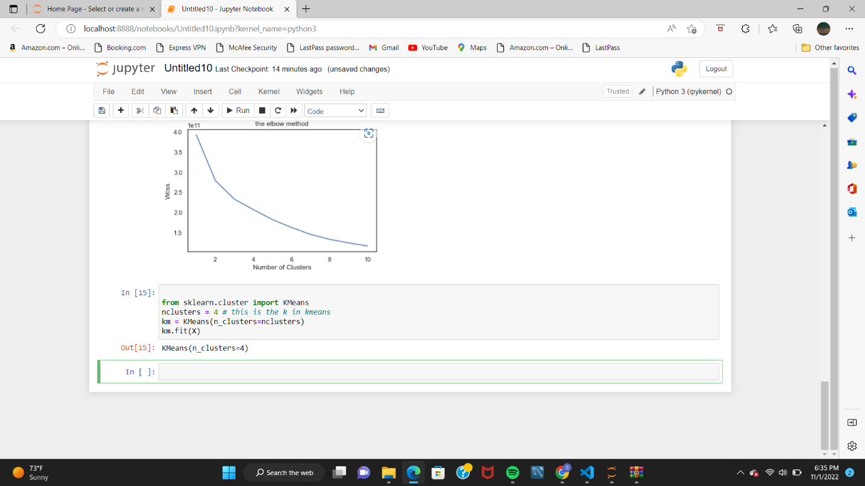

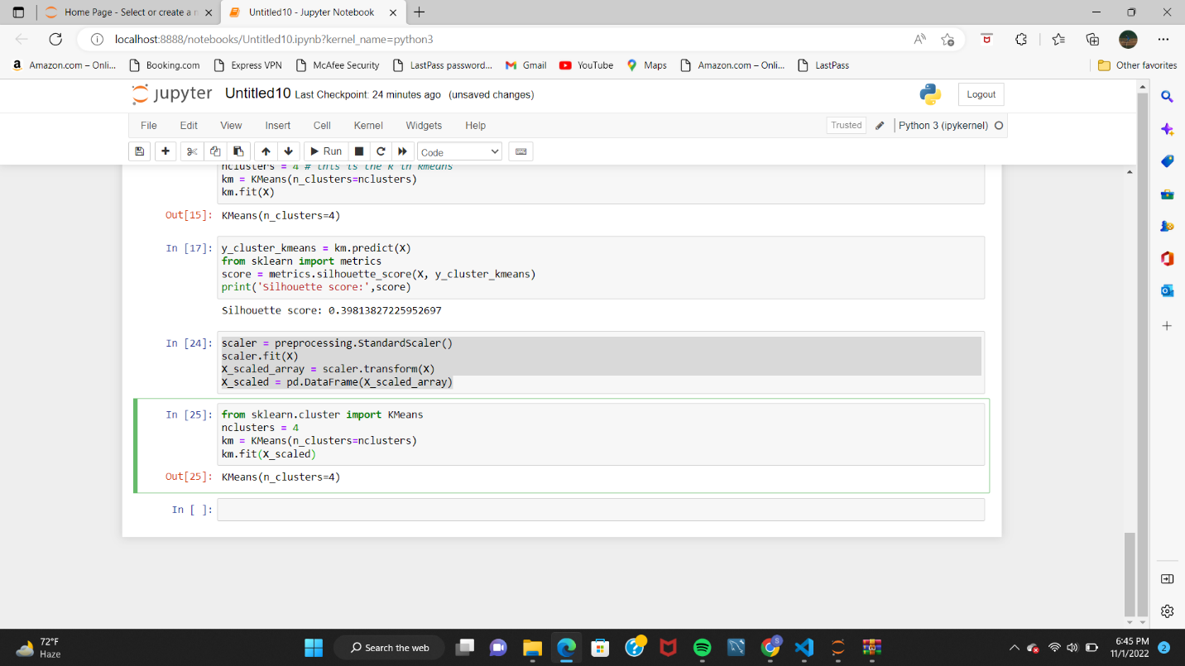

3. Try feature scaling and then apply K-Means on the scaled features. Did that improve the Silhouette score? If Yes, can you justify why



